SOP-5 Manage Permission Change Requests

REVISION HISTORY
Version | Modifier | Date | Comments
0.1 | Matias Fontecilla | 2020-08-20 | First draft
1.0 | Matias Fontecilla | 2020-10-14 | Official publication

Description and Scope
The following document describes the process to handle any permission change requests in EPC, from the moment when a request is made until the moment the request is closed.

Purpose
User permissions needs may evolve beyond their initial onboarding. This process exists to manage those changes. It also serves to handle any steps that may have been missed as part of the initial onboarding process.

Procedure
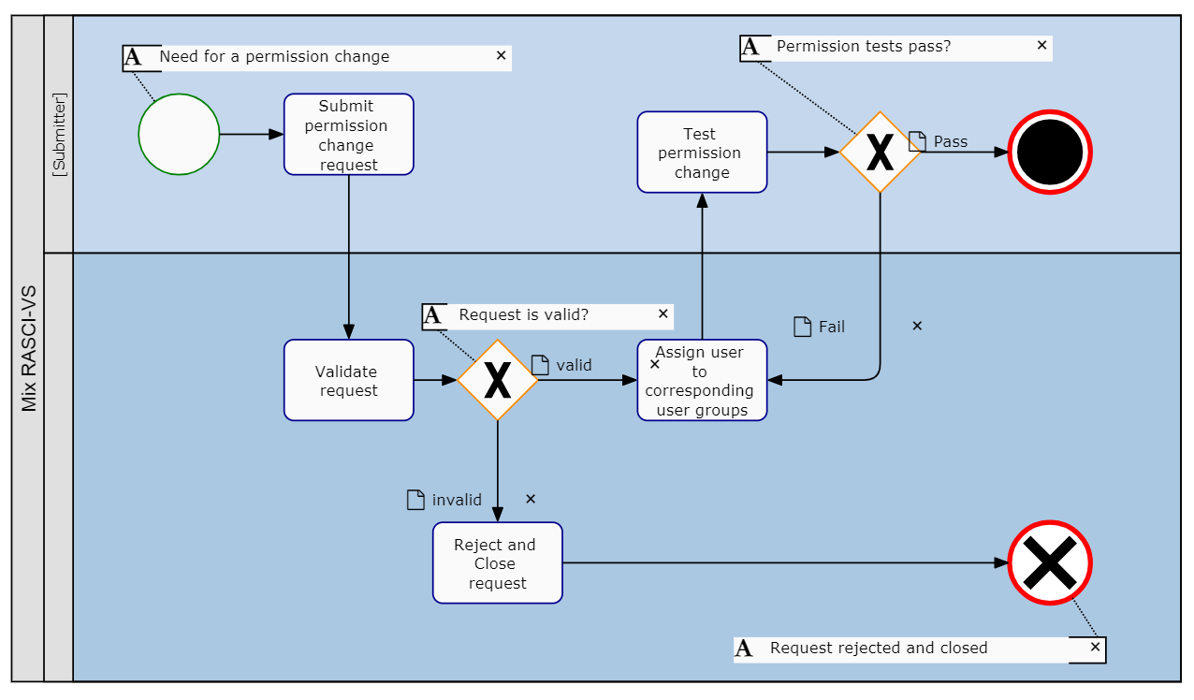

Submit permission change request
The user requiring a change request must submit a request through the means that are available, such as a request form on the EPC landing page or by contacting an EPC administrator.
Here, the submitter must be clear with what they wish to accomplish so that the administrator can place them in the most applicable user group(s).

Validate Request
The administrator responsible for fulfilling the request must first validate the nature and legitimacy of the request by following up with the proper chain of authority.
Here, they must determine:
- If the user has the authorization to have such permissions
- If this creates a potential EPC licensing conflict (i.e. not enough licenses). In such cases, this may trigger the need to request additional licensing and/or to verify if other users can give this user their licenses.

Reject and Close Request
If the request is considered as invalid, the administrator must communicate this to the user and close the request.

Assign to corresponding user groups
If the request is considered as valid, the user may be assigned to the most appropriate user group(s).
User permissions are managed at the group level. Therefore, users must be assigned to one or more groups depending on their roles. Please consult the Architecture Governance Document for the full breadth of groups and their settings.

To assign a user to a group
- Navigate the cursor and select the icon for the Group you want to add users to
- Navigate to the “Select a Group” search box
- Type the name of the Group you want to add to the User. “Double Click” on the group to finish adding it
- The added group will appear on the following table. The system admin will receive an automatic notification when the group is successfully added
Once this is complete, the administrator communicates this back to the submitter for them to test the results.

Test Permission Change
The submitter must test their permission change as part of this process. Here they must validate that they now have the correct permissions.
Note: this may require closing the user session by logging out, closing the browser tab and logging back in.
The submitter then communicates back to the administrator to indicate the results, which may either close the request or require additional user group assignment.

