Lighter SOP: Process order payment
Owner(s) : | General Manager;
Version: | 0.0016
Last Modified by : | Matias Fontecilla (matias)
Last Modified Date: | 2020-11-25T18:38:49.610Z

Associated Documents

- Work Instructions for processing a sale.docx

Goal
The goal of this process is to offer a quick method for processing orders. This process must handle the most common payment methods and must ensure that customers are provided all the essentials: A receipt and, in the case of cash payments, exact change.

Description
This process covers the steps to process a customer's payment for their beverage order. Given that there is more than one payment type, the process begins with a divergence where one path is for cash payments and the other is for card payments.

Process / Subprocess: Process order payment

Flow Overview

Seq # | Name | Type | Roles | Documents
5.1 | Order payment method received | START | - Cashier
5.2 | gateway | GATEWAY | - Cashier
5.3 | Select a terminal and enter amount | TASK | - Cashier
5.4 | Process card | TASK | - Customer
5.5 | Collect cash payment | TASK | - Cashier
5.6 | Enter cash amounts and denominations | TASK | - Cashier
5.7 | Place cash into register and provide change as needed | TASK | - Cashier
5.8 | Order payment processed | END | - Customer

Procedures & Descriptions

5.1 Order payment method received
This sub-process is triggered once the cashier receives the client's preferred payment method.

5.3 Select a terminal and enter amount
With the Credit/Debit payment type, a customer has the choice to pay for the entire sale with their credit or debit card or pay for a part of the sale and use a combination of other payment types for the remaining balance.
- Click Credit/Debit.
- Enter an amount, select a terminal and click Start Payment.
- Process the card at the terminal.

5.4 Process card
Chances are the customer will know how to process their card. Otherwise, here are some detailed instructions:
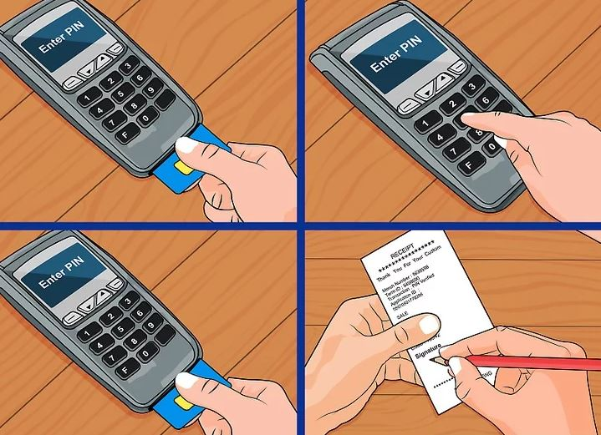
Enter your card's chip and enter your PIN (as one option). This is available for both debit and credit cards.
- Enter your card through the chip side
- Confirm the purchase amount
  - If using a debit card, select whether you wish to use your checking or savings account
- Enter your PIN and select Enter
Swipe your card and sign your name (as another option). This is only available for Credit cards.
- Swipe your card on the magnetic band side
- Confirm the purchase amount
- Once completed, the clerk will provide you with a receipt to sign

5.5 Collect cash payment
How to Count Change
Counting change back to a customer is actually pretty easy when you understand what you’re doing.
There are a couple of ways you can count change. First, you can read the number on the cash register and count that amount to the customer. This ensures you grabbed said amount. Second, you can count up from the sale total. This ensures the customer actually gets the right change back.
The number on the cash register:
If you count the the number on the cash register, all you’re really doing is ensuring that you got that amount from the register. But what if you entered the amount incorrectly to begin with? Then your cash register’s displayed amount will be wrong and so will the amount you hand to the customer.
Counting up from the amount tendered:
There is no way you can go wrong with this method. Let’s say the total is $7.38. The customer hands the clerk a twenty. She doesn’t have to know what the change is going to be – she doesn’t have to do any subtraction. All she needs to do is count up from $7.38.
Steps to Count Change
- Start with the pennies to reach a multiple of 5 or 10.
- Next use a nickle or a dime as you get to a multiple of 25.
- Use quarters until you reach a dollar.
- Use one dollar bills until you reach a multiple of 5 or 10.
- Use five dollar bills until you reach 10 or ten dollar bills until you reach 20.
Example: the process looks like this
The clerk counts to herself 7.39, 7.40, as she takes two pennies. 7.50, as she takes a dime. 8.00, as she takes two quarters. 9.00, 10.00, as she takes two ones. 20.00 as she takes a ten. Then she should count it back to the customer in the same way. Rather than offering the customer $12.62, she should count it back from the total.

5.6 Enter cash amounts and denominations
If your customer is paying for the entire sale in cash:
- From the payment screen, click Cash.
  - 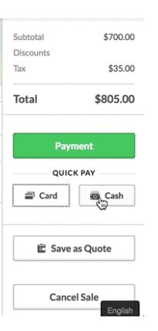
- Enter the amount of cash your customer has handed you by clicking the cash denomination buttons, entering the amount or clicking the MAX button. The Balance amount indicates whether you need additional cash from your customer or owe your customer change.
  - ​​​​​​​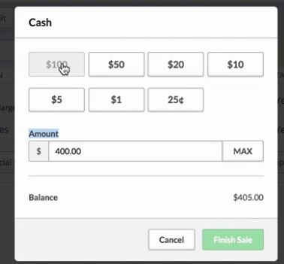
- Click Finish Sale.

5.7 Place cash into register and provide change as needed
Provide the customer change as needed based on the amount provided to you. When you have a choice, provide larger denominations; smaller denominations come handy for smaller purchase amounts.

5.8 Order payment processed
The payment has been processed, marking the end of this sub-process.

3 Process Maps (Empty if DNE)
Process / Subprocess: Process order payment
